Burning on the Street, Fuelled on the Net
------The Internet and public expression in China

Introduction

In early April, 2005, a message containing the following information was swiftly spreading via email, BBS, QQ, MSN and cell phone text messaging in Beijing.

An anti-Japan demonstration would be held on April 9th, 2005.Any Chinese
with conscience is expected to join. This demonstration is self-organized by some
patriotic students. Please gather in front of Sea Dragon Market, demanding the boycott
of Japanese electronic/IT products. We people in the capital could not remain indifferent
when nationwide anti-Japanese products emotion is so high. Thus patriotic students
are organized to demonstrate and publicize the boycott of Japanese products. Patriotic
behavior is legal. (But be careful that some people use this chance for stirring unrest).
Beijing TV Station would be informed. 20,000 people are expected to appear. The whole
world is going to know that Chinese people is still a powerful giant dragon. For patriotism,
please forward this message to at least 20 people. You are very much appreciated.

On April 9th, about 20,000 people went on street. Though official media kept silent about the demonstration, people across the country still got to know what had happened in Beijing--- reports, pictures and discussions filled Chinese internet chat rooms and BBS. Repercussions on the net caused more demonstrations on the streets during the following week in Guangzhou, Shenzhen, and Shanghai. Chinese and Japanese governments rushed into making reactions.

Anti-Japan demonstration in this past spring is merely one example of how the Internet is used to shape and express public sentiments in China. Today opinions in the cyber space have become more and more intrusive into Chinese public discourse. “This would be really something unimaginable just several years ago,” says one researcher to a mainstream Chinese newspaper, “Netizens are unprecedentedly active that opinions about domestic or international events are formed immediately (after the happening) on the net, producing huge pressure that could not be neglected by governments, organizations and public figures”.

Is the Internet changing Chinese politics? If so, in what way and toward which direction? How to understand the relationship between the enlarging net expression and the tightened government intervention into the cyber space? This paper would focus on the Internet and public expression in China. I would argue that as real, extensive yet incomplete representation of public sentiment, net opinion is gaining more and more weight in Chinese political discourse and decision making process. Still, it is much early to believe that the Internet would bring western type democracy in China. The political use of the net and government effort to manage it open a window for us to see the interaction between the new media and the state. Six issues would be examined below: media and state relations in China; the Internet and its Chinese users; net opinion as public expression; social and political effects of expression on the net; the Internet and overseas Chinese; and finally, government management of internet expression.

New Media vs. Old State

The Internet is believed by some in western societies as an inherently democratizing technology, detrimental to the rule of what they call authoritarian states. News, ideas and images conveyed by this new media into close societies would produce fundamental social and political change in a way favor the people over the government. "Technology will make it increasingly difficult for the state to control the information its people receive," said Ronald Reagan soon after stepping down as America's president: "The Goliath of totalitarianism will be brought down by the David of the microchip“. And his statement seemed proved by the tales of using fax machines and satellite TV during the fall of the Berlin Wall. Expectation on the Internet ran high again when Colin Powell asserted before the US Congress that "the rise of democracy and the power of the information revolution combine to leverage each other."

It is however difficult to establish causal linkages between the diffusion of the Internet and the emergence of real democracy. Shanthi Kalathil and Taylor C. Boas pointed out in their excellent report to the Carnegie Endowment for International Peace that no significant body of scholarly work has sought to address the widespread popular belief that the Internet will undermine authoritarian rule. Researchers do found a significant correlation between democratization and Internet users per capita in which political change is a determinant of Internet diffusion, not the other way around. These works raise serious questions about the relations between the new media and the state in developing world.

Can the new media change the politics in authoritarian countries? And if yes, how? Supposing that the Internet does lead to more political openness or even democracy. Then to what extent and with what conditions? To answer these questions, one should employ fair evaluations about the development of the Internet and accordingly the state reaction against it under specific context of a certain country, instead of taking for granted an optimistic or a pessimistic view.

There goes a Chinese saying to applaud the diverse and vibrant situation of opinions—one hundred flowers blossom and one hundred voices contend. Nonetheless the history of controlling political expression and communication in Chinese history only made that situation a transient beauty. Stories of making hush punishment for words were not rare. The Qin emperor buried Confucius alive and burned their books; the great Qian Long emperor imprisoned scholars only for their writings. It became an intellectual experience and a mass belief in modern China that the general public were better not talking about state affairs. People keeping silent just like chilled cicadas happened before and after the establishment of PRC.

Modern Chinese news philosophy not only reflected the long Chinese tradition of state over the media, but was also strongly influenced by the national goal ever since mid 19th century. If the freedom of speech or of press embodied the enlightenment effort by the liberals at the turn of the 20th century, the argument that the press should serve the state for a nationalist goal finally prevailed, legitimatizing official management of the press. Given the paramount need to save the country from internal division and foreign aggression, the media has ever since been regarded as a tool of political leaders to mobilize, organize and educate the public, rather than a watchdog barking for government wrongdoings. The Communist Party’s journalism partly echoes that nationalist theme. The media is expected by the CCP leaders to play a mouthpiece role, promoting social stability and public support to government policies. This is still very true after Deng Xiaoping’s reform, in which a moderate surveillance role by the press could be accepted by the government. The Chinese leaders insist that news media should be firmly grasped by the party, serving for political stability and national rejuvenation. Chinese journalist textbooks advocate to compromise media freedom for social and political responsibility.

In sum, the new media emerged here in an old state, where strong authoritarian and communist tradition guide information dissemination and communication. Progress in freedom of speech can only be measured against the above historical and philosophical background. A stifle scenario tends to deny the improvement brought by the Internet in China and its positive implications on Chinese politics, thus neglecting the dynamics instilled by the new media to change state power; while a revolutionary scenario exaggerates the democratizing function of the Internet, putting aside constraints by the old state. However, the two scenarios are both true in China, as what can see from discussions below.

The Internet and Its users in China

China was firstly connected with the global Internet in April 1994. From then on, the net industry generally developed very fast despite the burst of the Internet bubble. Ding Lei, Netease Company’s President and CEO, a young man in his early 30s, was regarded by the Forbs Magazine as China’s most rich in 2003, symbolizing a high peak of the net economy. Behind the success of this “eyeball economy” are hundreds of millions internet users, who not only make people like Ding Lei economic rich, but make the net politically powerful.

According to China Internet Network Information Center (CINIC), the Internet users in PRC have been increasing at rapid rates and now are over 100 million (see table 1), perhaps the second largest in the world (see graph 1). International data bandwidth and computers connected with the Internet are also growing dramatically (see table 2, and 3), making it much easier for Chinese netizens to communicate with domestic and foreign websites and users.
Graph 1
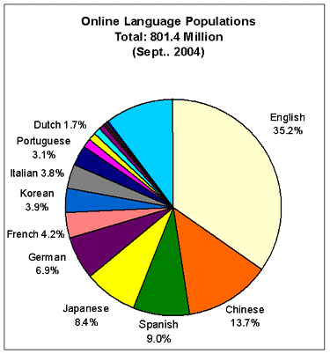
Source: www.global-reach.com

January 2005 statistics show that most Chinese net surfers are young, educated, male people living in urban area (see graph 2, 3 and 4). Over half of net users are between 18 and 30 years old, and more than 80% of the net-using population is under 35. Nearly 90% netizens have attained at least a high school diploma. Only 1% of them are farmers and peasants （see table 4）. Student users occupy about 1/3 of the net population. This composition has significant meaning in understanding the representation and emotions of net opinion in China.

Graph 2
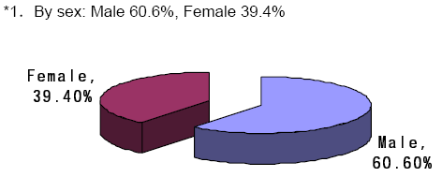
Graph 3
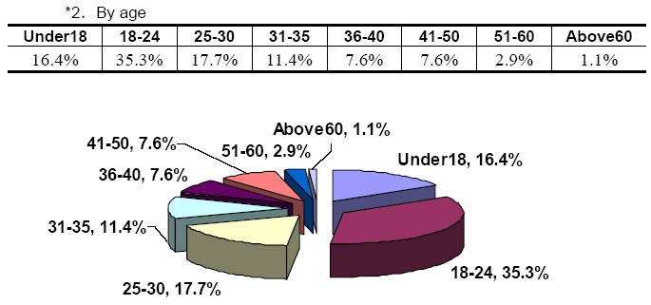
Graph 4
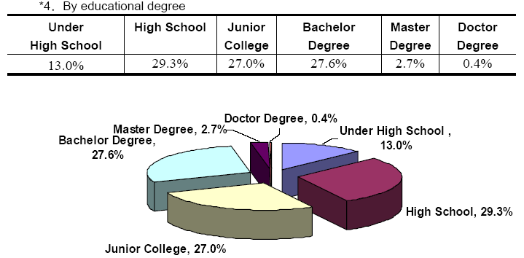
Table 4
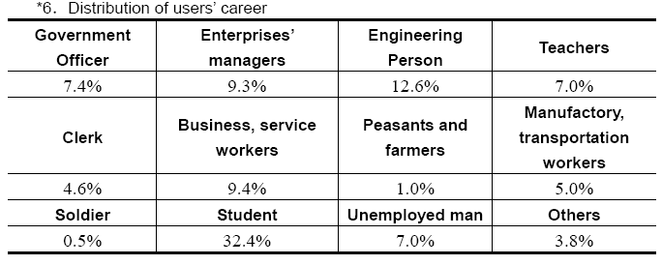
Average netizens in China spend 13.2 hours per week in the cyber space, basically for getting information (39.1%) and being entertained (35.7%) (See table 5). Investigation shows that Chinese net users rely a lot on the Internet as information source---98.5% respondents say that the Internet is main tool for obtaining information, thus giving the net an important position as a key source in opinion formation. 82.6% Chinese netizens mainly visit domestic Chinese websites; 4.7% of them visit domestic English websites; 7.0% visit overseas Chinese websites; and 5.6% visit overseas English websites. Major Chinese commercial portals like Sina.com, Netease.com, Sohu.com，etc. are most frequently visited websites.

Table 5
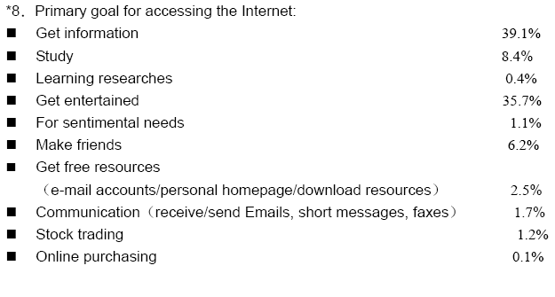

The Internet however is not just where people receive information or amuse themselves, it is also a place that people express themselves and interact with others. Email, chat rooms, BBS and text-messaging are mostly used online communication methods, according to CINIC analysis. Mainstream Chinese websites allow people to post comments after news items, lifting eyeball attraction by encouraging interactive and multi- directional exchange of information and ideas. In 2003, for instance, over one million messages were left at major websites, commenting on a news report about a traffic incident in Harbin which might involve corruption. The Strong Nation Forum received 12,000 comments within the first 24 hours after 911.

In short, explosive growth of the Internet infrastructure and net users has brought a new outlook over opinion formation and dissemination in China. The Internet is used as not only an information aggregation tool, but a major platform for public expression, thus producing a new term---wang luo yu lun (net opinion). While people in different countries are using the Internet expressing themselves, net opinion in China has some specific features related to public sphere in construction and present social and political trends, which might be called net opinion with some Chinese characteristics.

Net Opinion as Public Expression

Net opinion in China first got attention as the “yellow ribbon movement” in 1998, when domestic and overseas Chinese expressed their anger over serious riots against their fellowman in Indonesia. In May 1999 during the embassy bombing incident in former Yugoslavia, online protests were so strong that the People’s Net established the first BBS, which later became the famous Strong Nation Forum, in a website of traditional mainstream media. Since then on, public use of the net for discussion on social and political issues became common. And it seems that people are getting more and more interested in online expression---CINIC survey shows that people frequently using BBS went up from 9.0% in 2001 to 23% in 2005.

As mentioned, BBS and news follow-up messages are basic ways of opinion expression on the net. One study found that most BBS topics came from original posted messages from net users, rather than from responding to traditional media (see graph 5). Hot web news and comments are disseminated or forwarded in a broad range through email, QQ, MSN and other means including text messaging. When net opinion on a certain topic became strong enough, online petitions might be seen as an escalation of expression, as happened in the Sun Zhigang case in 2003. It is claimed that over 40 million signatures were collected online within less than two months in the petition against Japan’s efforts to become a permanent member of UN Security Council.

Graph 5
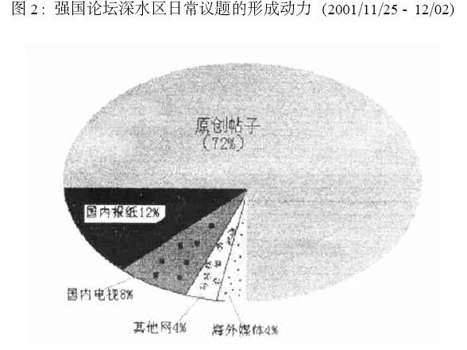
Many people have high expectations on the role of the Internet in political participation. 60.8% netizens and 61.5% non-netizens agreed that by using the internet, people got more chance to criticize government; 79.2% netizens and 77.4% non-netizens supported that using internet made people understand politics better; 72.3% netizens and 73.3 non-netizens believed that government officials would know better of public opinion through getting access to the net; and 71.8% netizens and 69.7% non-netizens regarded that internet brought more opportunities for political expression. Another research revealed that over 60% respondents agreed that people had a better say on governmental affairs by using the internet, the only exception that formed a majority among 9 countries (see graph 6).

Graph 6
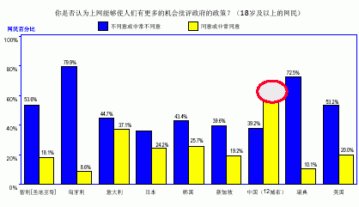
Source: Guo Liang: The development of The Internet in China and its Effects on Public Opinion (zhong guo hu lian wang de fa zhan ji qi dui min yi de ying xiang), a speech made at Yale University Law School, April 26th, 2004.

The high expectation and surge of online opinion surely has something to do with current situation of political communication in China. First, as several researchers pointed out, formal institutional channels did not play well incorporating popular opinion into political process. Second, traditional media are more inclined to reflect governmental or elite opinion, marginalizing mass expression. And they don’t bark aloud enough as watchdogs. Even if traditional print or electronic media are enthusiastic to show public concern, they are restrained by gate-keeping, unilateral communication, lack of space or time, and insufficient interaction. The Internet, in contrast, provides a convenient, open, equal, interactive, and instantaneous way for ordinary people to show his/her happiness, frustration, excitement and rage.

Yes, net opinions in China are usually emotional. Rational and wise suggestions are not rare in the caber space, but online discussions are often colored by bitter words. Some people use critical realism and nationalism to describe those who are tough on the net, and gave them a name feng qing (angry youth). Some others characterize this phenomenon as “collective extremism”. Why so much anger? No simple answer---perhaps social, psychological and institutional factors are involved. What should be emphasized is that dissatisfactions and criticism on the net related to domestic issues are no less than nationalist feelings, making the argument groundless that Chinese government is encouraging net nationalism. Actually net opinion going extreme is not something unique in China. As one American said, “if you read U.S. chat sites, you would tend to think that everyone within the U.S. is racially biased and so on and so forth.” Extremism is something of concern, and this sets up excuse of harnessing net opinion. But I tend to argue that extremism could only be marginalized by more openness, not limitation or even stifling. We simply could not give up eating for fear of choking.

What is more important is that if these emotional opinions on the net are truly representative. On the one hand, quite a few people tend to believe that net opinions are real reflections of what are in the mind of the net users. “anonymity and concealment make most people on the net tell their true thinking”. The internet provides an open forum to show what people have difficulties expressing themselves in traditional media and institutional channels. “In the posted messages are public opinion and social mood with original taste”, said one net user. Net opinions are also extensive. As we have shown, netizens in China now reaches more than 100 million, and continues to grow at rapid paces. In some big cities like Beijing and Shanghai, net users are more than 30% of the local population. It’s an important minority. On some specific issues, people who offer opinions form such a large number that it is hard to question the effectiveness of representation.

On the other hand, however, net opinion is also incomplete in terms of representation. First, the digital divide is there. Chinese netizens just occupies less than 8% of the whole population, a sliver of the national demographic, and as shown, most of them are young educated urban male people under 30. Given the high homogeneity of age, education and career background, their opinions could not be regarded as naturally equal to those of others. Second, frequent BBS visitors are also a small part of the whole net users. According to one CASS survey, only 10.8% netizens often make comments in chat rooms or BBS; 38.8% seldom speak them out; 24.9% only look through without making comment; and another 25.5% simply don’t not visit chat rooms and BBS. Finally, when people even in China believe that net opinion has extremist tendency, there might be the silent spiral effect on the net, which makes the opposite opinions not fully shown.

Social and Political Effects of Net Opinion

Despite the incomplete representation, net opinion functions basically positive in today’s China. Rising expressions on the net benefit social justice and stability. Popular participation into political process is enhanced. There are more openness, transparency and efficiency in governmental affairs.

The internet functions as an outlet valve which enables people to air their discontent or grievances. Research shows that when emotions were channeled out, discussions on a certain topic in the BBS tended to wane, and social structure maintained safe. This argument is supported by social conflict studies. If we admit that formal institutions and traditional media do not play well enough in China for popular expression, the safe valve argument is especially meaningful to social stability.

Net opinion is sometimes positive too in promoting social justice. Online discussion about Sun Zhigang’s case brought huge popular pressure on the government and led to a significant legal revision in 2003. The Supreme Court, in another case, made a very rare review and change, under extensive net opinion, of a verdict by a local court. Substantial justice prevailed, though legal researchers questioned the legitimacy in terms of procedure. In both cases, people saw interactions between the new media and traditional official media, with the former often driving the agenda of the latter.

Broader public participation into political affairs is also made possible through the Internet. When more and more netizens speak out in the cyber space, formal institutions become accommodating of net opinion. 46 year old Zhou Hongyu was first Chinese People’s Congress member who established personal website to interact with net users. Half of his 21 initiatives came from netizen’s suggestions. Major portals and mainstream media websites now frequently invite net users to vote on all kinds of hot issues. Increasing government departments adopt online evaluation of their performance, and the results are open. In January 2003 Shenzhen Mayor had a well-known meeting with a net user after the latter wrote on the net an article about that city’s problems and direction. Enhanced public participation urged government to be more responsive, transparent and efficient. Taking SARS as an example, the Internet played an important role in exposing the truth and calling for responsible measures.

Net opinion has already been part of decision making process. It provides decision makers not only raw information, policy alternatives, but also feedbacks. Chinese President Hu Jintao and Premier Wen Jiabao admitted in spring 2003 during the SARS that they received and appreciated suggestions from the net. Public dissatisfaction firstly appearing from the net led to resignation of Minister of Public Health. Government branches now pay attention to extensive rather than sporadic net opinions in their internal newsletters. Chinese Foreign Minister Li Zhaoxing had a 105 minute long interaction with netizens in Dec. 23rd, 2003. He frankly admitted that views from the net had important values of reference and that the argument on whether Chinese diplomacy was too soft or too hard had made him think deep.

Net opinions however are surely not all positive and constructive. There are rumors, personal attacks, irrational and irresponsible comments. Sensational or disturbing information spread through BBS and chat rooms, no less hurting than viruses. Cynicism and nationalism are gaining clapping. Legal procedures may be under extraordinary pressure when opinions surge on the net, and extremists may circumscribe governmental flexibility in international affairs. The internet is sometimes even used as an illegal weapon --- for instance, by hackers---to express sentiments. The expression of popular opinions on the net is a meaningful step toward more political openness, but there is still a long way to go toward constructive democracy.

The Internet and Overseas Chinese

It is estimated that there are nearly 30 million ethnic Chinese living overseas, including early and new migrants, students, and dissidents, etc. Many are also using the Internet for information, communication and expression, thus making a prominent online presence.

The Internet is playing a constructive role in terms of reconfirming the identities for the overseas Chinese. As one scholar wrote, “Through reading the latest headlines from China’s major newspapers, debating the political scene in China, discussing Sino-American relations on defense, responding to a view and a posting of a Chinese movie or following the histrionics of a particular actor”, identities is “experienced and imagined in very immediate and quotidian ways”. In the virtual space of the Internet, Chinese-ness is recalled and a China on the web is created. Chinese communities are established in the cyber space, out of China town. The use of the web by oversea Chinese makes us rethink about the assertion that the Internet only erodes nation state and fragments identities. The Internet can even contribute to rising Chinese nationalism from overseas, “recent examples whereby Chinese were believed to be threatened, discriminated against, aggrieved e.g. the Wen Hon Lee case in the U.S. and the issue of the foot-and-mouth disease in the U.K. and that of the Indonesian Chinese, all suggest a pan-global mobolisation of ‘Chinese ‘ people to redress these grievances”. That the online petition against Japan’s bid for UN permanent membership started from an oversea website is another illustration of this kind.

The Internet can be used, especially by some overseas groups, as an effort to weaken state power in China. Human rights activists, Falungong members and political dissidents take the advantage of the web to disseminate information that is regarded by the Chinese government as subversive. They also frequently use one-way and two-way email, BBS, and chat rooms for coordination, communication, or mobilization. According to a Rand Cooperation report, exile dissidents groups such as the Chinese Democracy and Justice Party uses email as the most effective method to transmit information. Overseas political activists also use the Internet to inform the international media about concerned happenings in China. Email is said as well to be a primary vehicle for various overseas Chinese groups to advance their interest with U.S. congress people, their staffs and executive branch officials. It is very much likely that the overseas dissidents, Falungong members and human rights activists engage in more use of the web for their causes in the future.

Even so, it would be misleading to believe that the Internet can decisively undermine government control over information in China and play down state power. First, the subversive use of the net enables small groups with limited resources to be visible and active, but only out of Chinese borders. Counter measures employed by Chinese government, as discussed later in this paper, can effectively prevent “harmful” information from reaching most Chinese people at home. Second, the Internet also provides a platform for dissidents to show their discord and rivalry among each other, weakening their images, legitimacy, and influence.

Government Management of Net Opinion

Chinese government responds to the rising internet opinion with both encouragement and restlessness. Public expression on the net is a pulse of the society on which the government could touch and measure. But when the pulse beats wild, the net should take some medicine.

That medicine is however not lethal. It is a misperception that Chinese government is doing everything it can to stifle expression on the net. When a Chinese researcher visited the Google for “China internet”, he got 3.42 million results, and more than 80% in the first 100 results were related to governmental suppress and control while only less than 20% focused on the prosperous internet industry. He argued that actually without governmental push, the rapid development of internet in China would be impossible. In fact, there is an underlying assumption in western countries that the Internet poses an insurmountable threat to authoritarian rule, while Chinese government is indeed adapting to the information age and enjoying the positive aspects. “There is little evidence that the development of a ‘new media’ sector is significantly eroding the authority of the state, or giving rise to overwhelming political challenges”, one American researcher wrote in paper on the new media in China.

Chinese government has been encouraging to the development of the Internet and public use of it. For one reason, informatization is regarded as important not only to economic development but to the harmony of the whole society and the improvement of governance. E-government, for example, promotes more transparency, efficiency and feedback. Internet expression also establishes sometimes a rare direct communication between government officials and the mass public.

Expression on the net is however also politically dangerous. False information appears; expression frequently go emotional and extreme; net opinions are divergent and centrifugal, making it hard for political persuasion by the party; and domestic and overseas political dissidents use the internet for subversive purpose. All these call for more administration. Nonetheless the bottom line of government management of the new media now is not a total control but political safety.

The government employs both proactive and reactive means to channel or check net opinion. One method is to strengthening mainstream official media websites to compete with other domestic and foreign information sources, so as to maintain a strong role of the state in shaping information environment. Since the year 2000, 8 traditional media websites at the central level and 24 news websites at local level have been identified as “key websites” and got support from Chinese government. These websites offer about 24,000 pieces of news daily and receive more than 50 million visits per day. Some of them, like the www.xinhuanet.com, www.people.com.cn, and www.CCTV.com, etc., have already been listed in the first 100 most frequently visited websites worldwide.

Another approach is to allow a degree of “healthy” discussions in the loosely controlled BBS and chat rooms. That’s one reason why BBS and chat rooms flourish in China. The most famous BBS---the Strong Nation Forum--- is actually on the People’s Net, which is People’s Daily website. When big events or highly disputed issues emerge, some BBS forum invite officials or experts to discuss and communicate with netizens, trying to lead the direction of net opinions. According to newspaper report, online commentators are recruited and trained so that voices online be “rational”. Nuanced channeling is believed better to “thought work” than simple checking---when sentiments are released before the buildup of mass frustration, the society becomes more stable, as argued before.

Restrictive measures used by the government to manage net opinion include basically three types. First, the government blocks by firewalls and the alike some websites, especially those pornographic and politically subversive ones, including some human rights organizations’ webpages, and websites such as of China Democratic Party and Falungong. Second, political sensitive or threatening content are filtered or deleted by monitoring BBS or chat room usage. According to Chinese rules, each BBS or chat room should have some net managers, whose responsibility is to insure information on the net clean. They screen and quickly remove offensive material from bulletin boards. But all kinds of message appear in the BBS and chat rooms that the effectiveness of monitoring largely depends on the judgment of the censor. Third, internet runners are asked to be more self-disciplined. In December 2003, for instance, more than 30 Chinese internet content providers signed an agreement against “harmful information that undermines social stability”.

How effective the governmental management is? The answer lies very much with willingness and expectations. If the objective is overall political safety and social stability, it is basically satisfying presently. But if management of net opinion aims at forming ideological consensus or wiping out unwanted information and opinions, it has never been successful. One survey shows that the percentage of Chinese net users who know proxy servers is rather high. That means wise enough netizens might have their own way to go around the firewalls etc.

Conclusions

The tide of the Internet opinion in today’s China is on the rise. People have better chance making loud voices on the net than on traditional media, though they are sometimes piecing and noisy.

The existence of net opinion is more constructive than destructive to changing social and political Chinese scene. Online public expression leads to more information liberalization, political participation and popular-supported decision-making. The state’s exclusive grip on information resources is loosened by surging opinions on the net. Discussions in BBS and chat rooms on social, economic and political issues compose part of emerging public sphere in China, and outlet social pressure. The distance between the government and the people is drawn shorter in the cyber space, even if it often means more frictions. If “wisdom comes from listening to different sides”(兼听则明), then we have no reason putting the Chinese government in the position against net opinion. In fact, the government is encouraging net expression while setting the rules of the game.

Western research seems more interested in the subversive role of internet expression in authoritarian countries, setting net opinion and political legitimacy against between each other. But expectations that the mere presence of net opinion will quickly lead to merciless suppress or western democracy are all unfounded. The Internet is now used in China to construct a socialist democracy under the leadership of Communist Party.

Message appeared on most BBS of Chinese websites in early April. This one was a translation from webpage http://net.51768.net/Article/xinwen/zhuanti/200504/965.html
See Southern Weekend (Nan Fang Zhou Mo), June 6, 2003
http://www.economist.com/PrinterFriendly.cfm?story_id=1534249 accessed at 10:45 am on March 23, 2006
http://skopje.usembassy.gov/confirmation_hearing.html
Shanthi Kalathil and Taylor C. Boas, The Internet and State Control in Authoritarian Regimes: China, Cuba, and the Counterrevolution, First Monday, volume 6, number 8 (August 2001), p1
See Gu Qian, The Conflict, Convergence and Coexistence of Chinese and Western Journalism, Fudan University Press, 2003, pp75-90
Net user is defined by CINIC as people who averagely spend at least one hour per week on the net. See CINIC report of Jan. 2005. All survey results in this paper come from CINIC reports unless sources are separately noted.
See “Net affecting Life: Chinese Netizens over 100 million” (Wang luo ying xiang sheng huo: Zhong guo wang min zong shut u po yi yi), http://info.china.alibaba.com 2005-05-20 10:16
See “Discussion with Min Dahong on Net opinion and public expression” (dui hua Min dahong: wang luo yu lun ---min yi biao da de ping tai), http://www.xinhuanet.com 2004-10-22 10:58:34)
Guo Liang: The development of The Internet in China and its Effects on Public Opinion (zhong guo hu lian wang de fa zhan ji qi dui min yi de ying xiang ), a speech made at Yale University Law School, April 26th, 2004.
See http://china918.net/qm/
A survey done by Chinese Academy of Social Sciences in 2003. See http://www.xinhuanet.com/2004-03-11 09:39:22/
Wang Yi: the value of net opinion in 2003 (2003 nian wang luo yu lun de jia zhi ); Discussion with Min Dahong on Net opinion and public expression (dui hua Min dahong: wang luo yu lun ---min yi biao da de ping tai), http://www.xinhuanet.com 2004-10-22 10:58:34);
Political Use of the Internet in China, p7; See Discussion with Min Dahong on Net opinion and public expression (dui hua Min dahong: wang luo yu lun ---min yi biao da de ping tai), http://www.xinhuanet.com 2004-10-22 10:58:34)
Guo Guanghua: on the collective extremism of net opinion holders (lun wang luo yu lun de qun ti ji hua qing xiang ), in Journal of Social Science of Hunan Normal University, Vol 33, No. 6, 2004
See The Impact of the Internet on Authoritarian Rules, presentation made by ShanthiI Kalathil at Carnegie Endowment for International Peace, June 25th, 2003, Q&A part
Zhao Bo and Zhao Zhenhuan: Effects and Management on Political communication of the Internet (Hu lian wang dui zheng zhi yu lun chuan bo de ying xiang ji zhi li dui ce ), Xue Hai, No. 6, 2002, p151. And Chen Tongxu , Peng Lifeng: Topics of BBS: Formations and Disintegration, a study of the forum Making the Nation Strong in People.com.cn, Journal and Communication, Vol 9, No. 1, 2002, p23
See “Discussion with Min Dahong on Net opinion and public expression” (dui hua Min dahong: wang luo yu lun ---min yi biao da de ping tai), http:www.xinhuanet.com 2004-10-22 10:58:34);
See Guo Liang: The development of The Internet in China and its Effects on Public Opinion (zhong guo hu lian wang de fa zhan ji qi dui min yi de ying xiang ), a speech made at Yale University Law School, April 26th, 2004.
Chen Tongxu , Peng Lifeng: Topics of BBS: Formations and Disintegration, a study of the forum Making the Nation Strong in People.com.cn, Journal and Communication, Vol 9, No. 1, 2002, p23
On March 17, 2003, Sun Zhigang, a 27-year-old college graduate who was working for a graphic design company in Guangzhou, was stopped by police. He was detained for not having proper identity papers and died in custody three days later. His case was picked up by a reporter from the Southern Metropolis News, and then hit the Net. Within two hours after being posted on China’s largest news portal, sina.com, this news item generated 4,000 comments from readers. Almost immediately, the case was being discussed throughout Chinese cyberspace, from official sites to personal Weblogs and e-mail groups. The official media, including CCTV, soon picked up on the public outrage and reported heated debates over treatment of migrants living in the cities and police corruption. On May 29th, in an unprecedented appeal to the National People’s Congress, four professors, including two from Beijing University Law School, called on the state prosecutor to investigate Sun’s death. Three months later, the government abolished the entire Repatriation system, and the officials responsible for Sun Zhigang’s death were convicted in court. See Xiao Qiang: The Rising Tide of Internet Opinion in China, in International Journalism, summer, 2004, p103
See “China faces net opinion double sword with ration” (zhong guo li xing mian dui wang luo yu lun shuang ren jian), http: www.xinhuanet.com/2004-03-11/09:39:22/
See “People’s Net article strengthens determination to uncover Sun Zhigang case” (Ren min wang wen zhang zeng qiang le zhen po sun zhi gang an de xin xi), in Southern Weekend, June 6th, 2003
See “Chinese Foreign Minister firstly interact with net users on foreign affairs” (Zhong guo wai zhang shou ci tong guo hu lian wang yu wang min jiao liu wai jiao wen ti), http://www.rednet.com.cn 2003-12-23 22:31:49
Loong Wong: Belonging and Diaspora: The Chinese and Internet,
Ibid,
http://www.rand.org/pubs/monograph_reports/MR1543/MR1543.ch1.pdf, p16
Ibid, p18
See Guo Liang: The development of The Internet in China and its Effects on Public Opinion (zhong guo hu lian wang de fa zhan ji qi dui min yi de ying xiang ), a speech made at Yale University Law School, April 26th, 2004.
Shanthi Kalathil and Talor Boas: The Internet and State Control in Authoritarian Regimes: China, Cuba, and the Counterrevolution, Carnegie Endowment for International Peace, First Monday, volume 6, number 8 (August 2001), http://firstmonday.org/issues/issue6_8/kalathil/index.html
Shanthi Kalathil: China’s new media sector: keeping the state in, The Pacific Review, Vol. 16, No. 4, 2003, p490
See “China successfully construct mainstream media on the net and lead net opinion” (zhu dao wang shang yu lun wo guo cheng gong da zao wang luo zhu liu mei ti), http:www.xinhuanet.com/2004-11-08 18:20/
See Southern Weekend, May 19, 2005, page 5
See “Net communication and surveillance: the example of net politics” qian tan wang luo chuan boy u yu lun jian du---yi wang luo zheng zhi wei li), http://www.qianlong.com/2003-12-18 15:32:02/,
See “China faces net opinion double sword with ration” (zhong guo li xing mian dui wang luo yu lun shuang ren jian), http: www.xinhuanet.com/2004-03-11/09:39:22/
See “The Use of the Internet and its Effects” (hu lian wang shi yong ji qi ying xiang diao cha bao gao), a survey done CASS in 2003. http://

