PKU Online Course Enrollment Guide
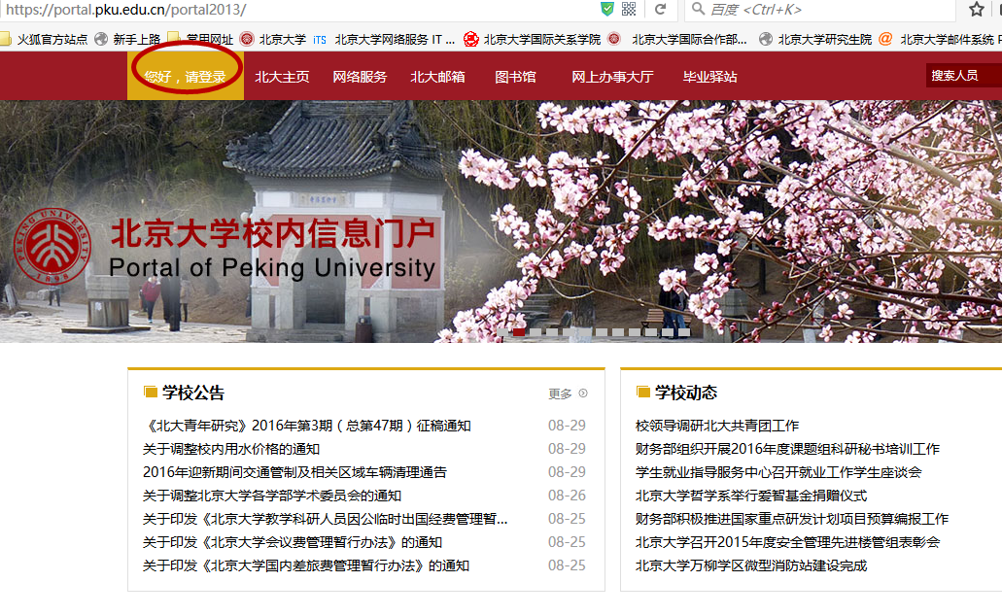
- Please visit https://portal.pku.edu.cn/portal2013/ to log in your personal portal by filling in your username and password accordingly.
Usename: your 8-digital student number
Password:

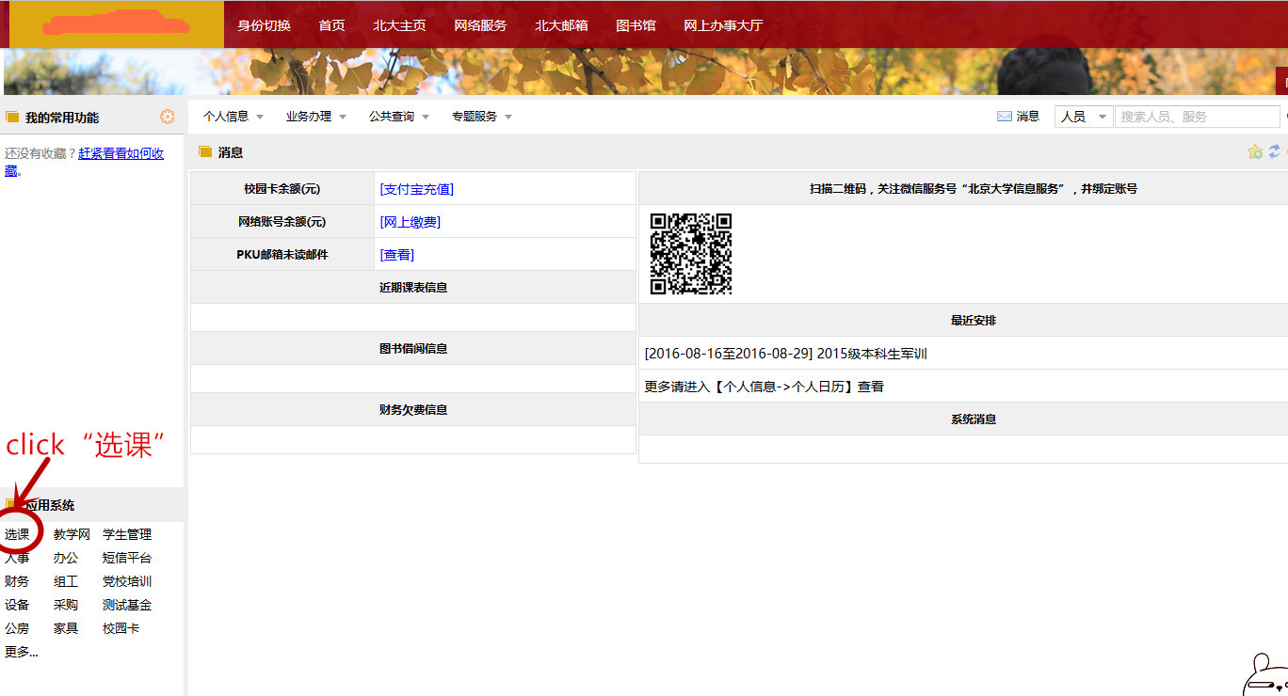
- After logging into your personal page,click“选课”：
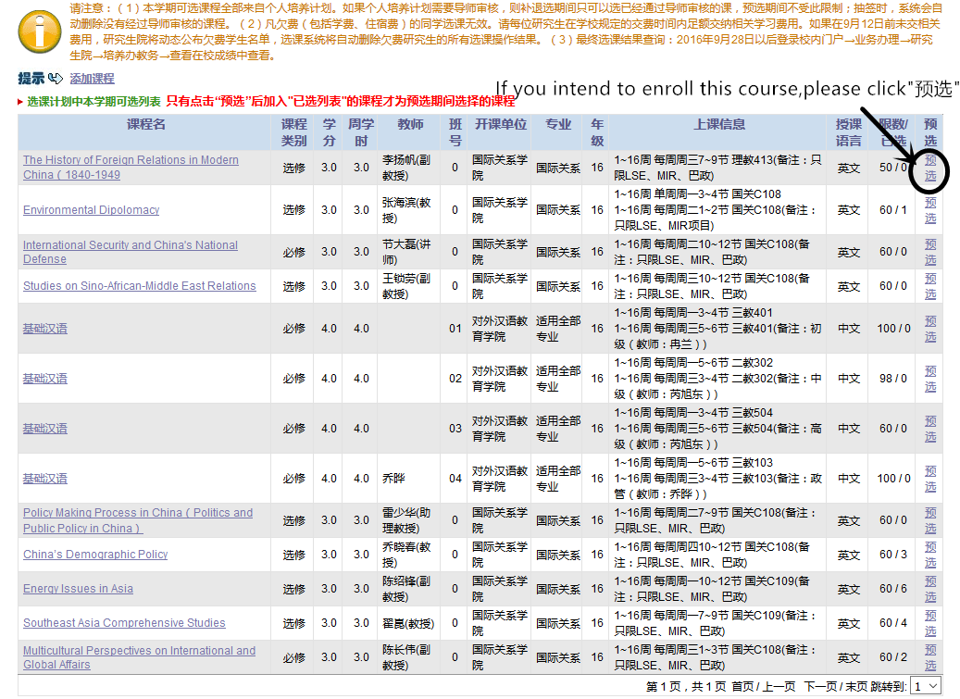
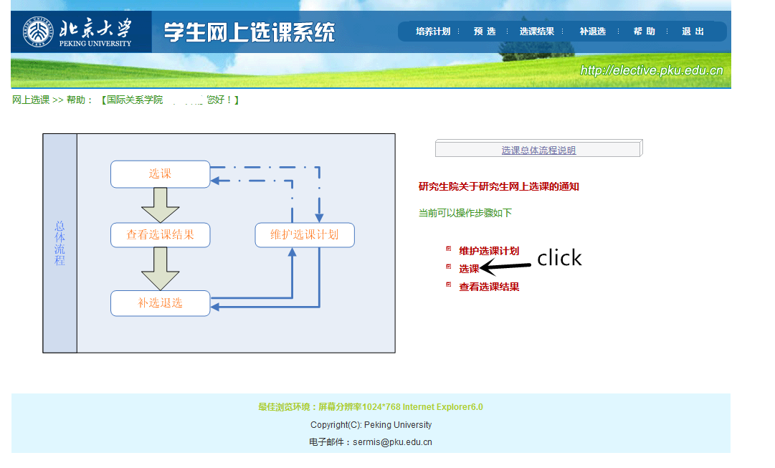
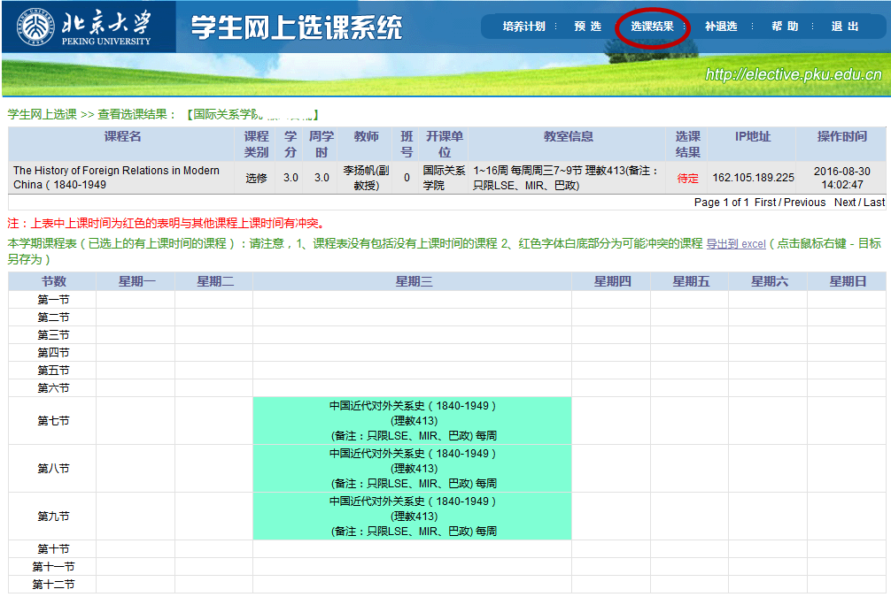
3）You can check your course selection result by click“选课结果”：

4）If you want to add or withdraw a course, please process it via “补退选”

