[www.pku.edu.cn](http://www.pku.edu.cn)



Click on 网络

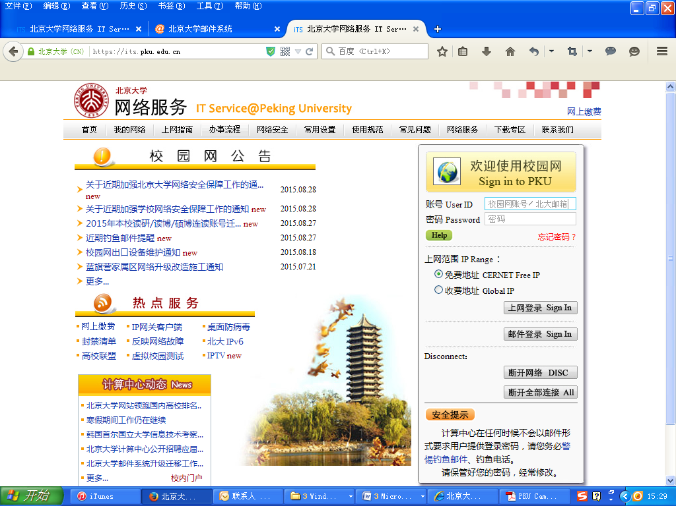

Put user ID and Password